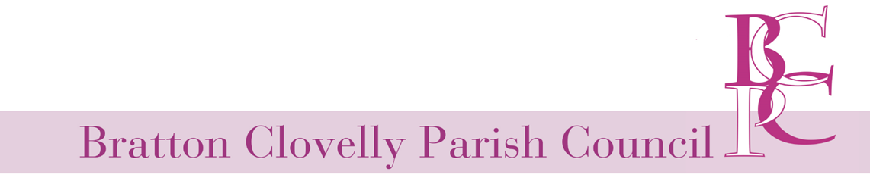
Minutes of Annual Parish Council Meeting and ordinary Meeting 203, held on Wednesday 18th May 2022 in the Parish Hall

Time commenced: 7.00pm
Those present: Cllrs. McNelis, Rocket, Gilbert and WDBC Cllr Southcott - Mrs R Ward (Clerk)
Members of the public: two
Public participation: None

Annual Meeting
1. Outgoing Chairman's Welcome: Cllr McNelis welcomed everyone to the meeting.
2. Election of Chairperson: Cllr McNelis was re-elected Chairperson, unopposed.
3. Election of Vice-Chairperson: it was agreed that the vice chair role would be filled on an ad hoc basis by the most suitable person at the time.

Ordinary Meeting
- Apologies: Cllrs Waters, Hughes and Levy.
- Declaration of interests: None
- Planning:
  - For Decisions - 1024/22/FUL Proposal: Change of use of land to domestic garden serving the dwelling Upper Metherell. Site Address: Upper Metherell, Beaworthy EX21 5TT No comment
  - For noting: None
  - Updates: None
- Agree and sign minutes from 13th April 2021: Agreed
- Resignation of Cllr Wallwork: Clerk to inform West Devon and post notice of vacancy
- Report form West Devon: £150 is starting to go out to household via Direct Debit. If you don’t have DD you will have to apply for the money. Vetting for Ukrainian refugees is ongoing.
- Finance: Receive up-to-date report on finances from RFO (Clerk)
7.1 Insurance quote: no longer fixed. Annual premium: £409.67 Annual Tax: £49.16 Total: £458.83 plus £50 arrangement fee total £508.83. Last year was £422.80
Agreed to fix this for three years.
  - To ratify the below listed payments:
Kerry Brookes Bin Bags for clean-up £4.25
To Note payment to WDBC Dog bin emptying £238.68 Agreed
To note and agree payment for Clerks salary including working from home benefit (non-taxable £26) and HMRC Payments – totalling £234.87, 4th April to 3rd May 2022 £187.87(clerk) £47.00 (HRMC Element) Noted
- Consider joining CPRE @ £60 pa: Agreed
- Web site: (Clerk report.) Vacancy and Audit will be posted in due course.
- WI Royal Jubilee Celebration – donation request: Agreed to pay up to £100 for jubilee medals for the children in the parish. Cllr Rocket to liaise with WI. Various activities going on for the Jubilee weekend: 14:30 Friday 3rd June there will be a walk along the pack horse trail followed by a cream tea at the pub - booking needed £10.00. 14.00 Saturday 4th June Picnic with live music and games, from 18:00 bar and disco.
- Playground: update (Cllr Rockett); the board has gone back on the climbing frame.
- Correspondence: none
- Date of next meeting: 08/06/2022 7:30pm in the Parish Hall

Signed Chairman ____________________ Date:______________

Clerk _________________________

